10 Primary Odor Classes

The e-nose classifier used the ten odor classes described as follows. These basic categories of odors were proposed by the researchers at the University of Pittsburgh and Bates College [1].
1. Fragrant
The fragrant smells are treated alike with perfumery, floral, cologne, and rosy smells. These are the ones that seem light and natural, what is typically described by perfume and cologne manufacturers as grassy or herbal.
i.e., Perfume, rose, cologne
2. Woody
This category refers to the deep, earthy smells that remind human of the outdoors. The smells are distinct in nature, which makes them easily recognizable. Musty, moldy, heavy, burnt, and smoky scents are included in the woody odor.
i.e., Mold, wood, grass
3. Fruity
Contrary to the hearty musk of the outdoors is the light, fresh scents associated with cherries, peach, strawberries, banana, and certain perfumes that draw upon natural aromas are classified as fruity odor. Unlike the sharp and bitter freshness of lemon, non-citrus fruit smells feel more smooth or silky to the nose.
i.e., Pineapple, cherry, banana
4. Chemical
The human nose is particularly very sensitive at detecting synthetic smells. These smells include ammonia, bleach, gasoline, paint, and felt tip markers odors. Alcohol and disinfectants are also under this category.
i.e., Gasoline, solvent, paint
5. Minty/Peppermint
The minty/peppermint smell is described as cool, refreshing, and exhilarating odor. It became synonymous with cleanliness and is ubiquitous among oral hygiene products for this very reason. Spicy odor falls into this category.
i.e., Eucalyptus, peppermint, camphor
6. Sweet
Diverging from sweetness detected in fruits, the aromas of things such as chocolate, vanilla, almond, honey, cinnamon, and malty scents are classified as sweet odors. They are warm, and often light. It is frequently sold as creamy or rich.
i.e., Vanilla, chocolate, caramel

7. Popcorn
Popcorn is considered as an earthy smell that is not quite grass or wood. It was grouped with other distinct smells such as peanut butter, burnt, nutty, heavy, and warm.
i.e., Popcorn, peanut butter, almond
8. Lemon
The scent of lemon, orange, and citrus connote freshness with a hint of sweetness and sharpness that makes it unique from the others. It’s light and acidic, and the human nose knows it instantly.
i.e., Orange, lemon, citrus
9. Pungent
These smells include sour milk, fecal matter (e.g., manure), sweat, and the natural smell of things that have turned putrid or foul. These scents make human reel the instant it is detected. Oniony and garlicky smells also fall into this category.
i.e., Garlic, onion, burnt rubber
10. Decayed
Decayed smells are those that cause to dry heave the person when the nose detects them in heavy enough concentrations. This category is not merely unpleasant. They are considered as usually insufferable.
i.e., Sour milk, vinegar, fecal

Reference:
[1] Jason B. Castro, Arvind Ramanathan, Chakra S. Chennubhotla. Categorical Dimensions of Human Odor Descriptor Space Revealed by Non-Negative Matrix Factorization. PLoS ONE; 8 (9): e73289 DOI: 10.1371/journal.pone.0073289, 2013.

Here is the list of the actual samples taken. A series of measurements was captured for each one. Five signals for each sensor was obtained and sent to the server for processing. This was repeated 3 times per sample. Thus, a raw data matrix 15x10 for each sample was obtained for subsequent processing or pretreatment. The 10 samples per odor class and 15 readings per sample collectively yielded a 1500x10 (readings by feature/sensor) available dataset. You can find the consolidated measurements in the same link.
Table I Samples per Odor Class
Class | Samples
Fragrant | 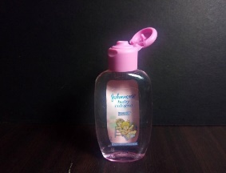  Cologne 1 | 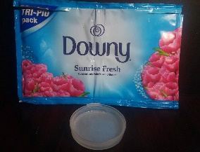  Softener1 | 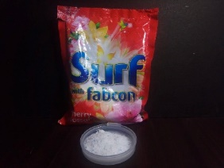  Detergent | 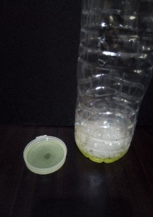  Liquid Soap | 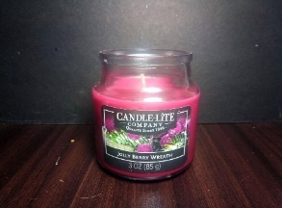  Candle1
 | 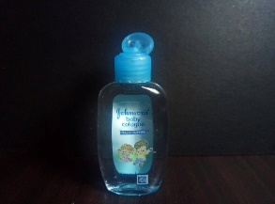  Cologne 2 | 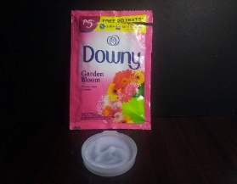  Softener2 | 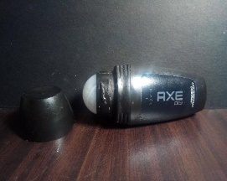  Deodorant | 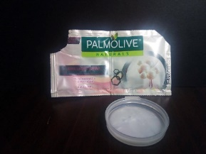  Shampoo | 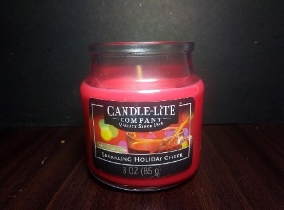  Candle2
Woody | 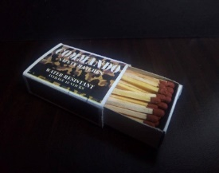  Matches | 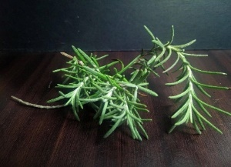  Fresh grass | 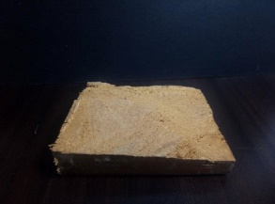  Wood 1 | 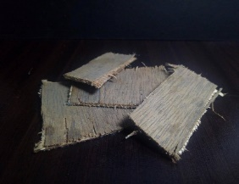  Wood 2 | 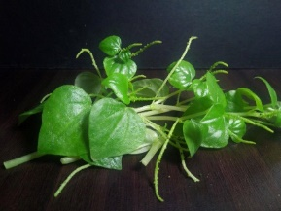  Leaves 1
 | 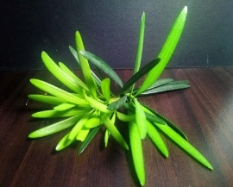  Leaves 2 | 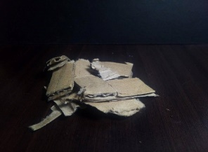  Card Board |   Cigar Pack | 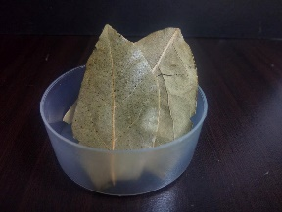  Laurel |   Wet Paper
Fruity | 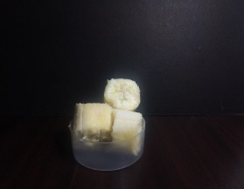  Banana | 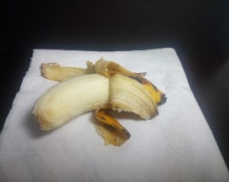  Banana 2 | 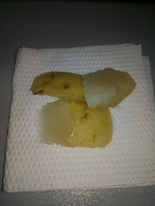  Pear | 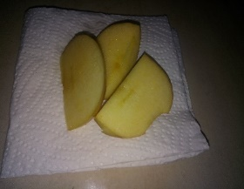  Mango | 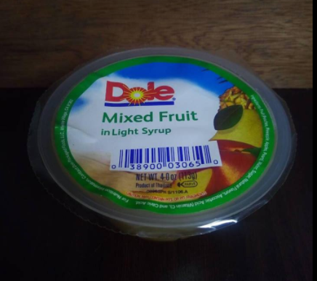  Fruit Salad
 | 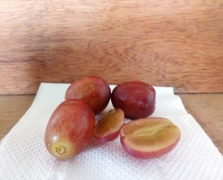  Grapes | 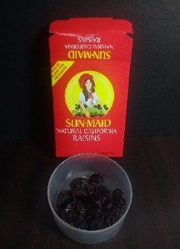  Raisin | 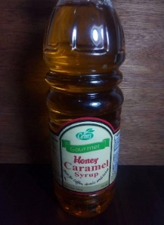  Honey | 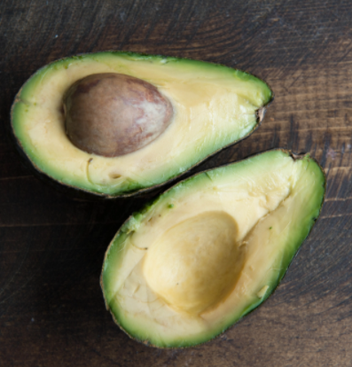  Avocado | 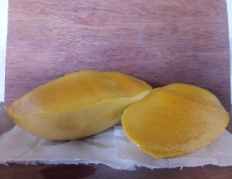  Mango
Chemical | 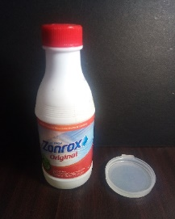  Bleach | 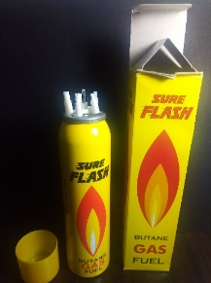  Methane | 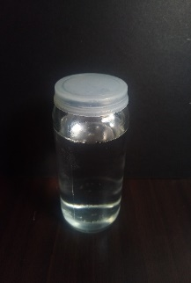  Alcohol | 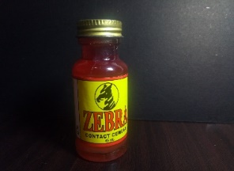  Rugby |   Disinfectant
 | 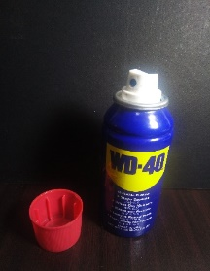  Lubricant | 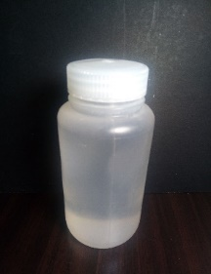  Gasoline | 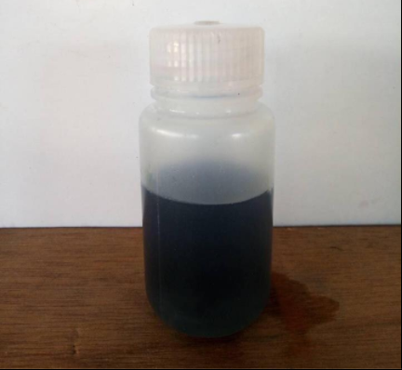  Diesel | 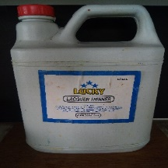  Thinner | 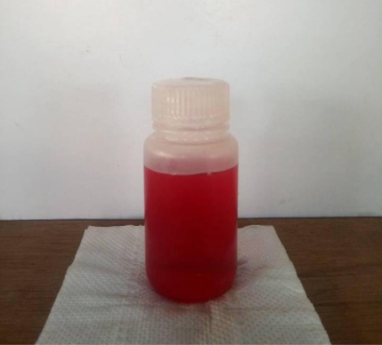  Sulfuric
Minty | 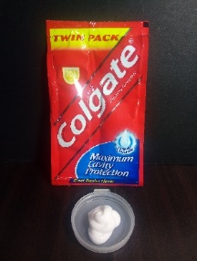  Toothpaste | 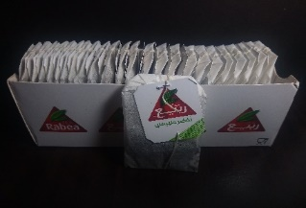  tea | 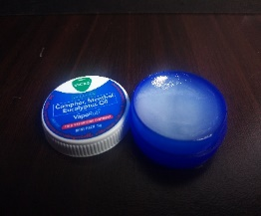  Vapor rub | 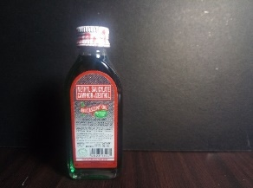  Oil | 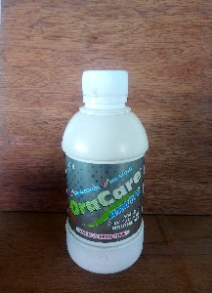  Freshener 1
 | 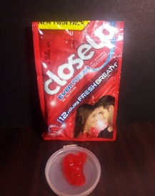  Toothpaste | 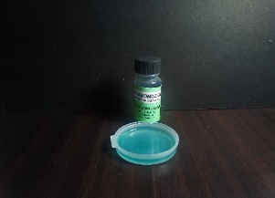  Acete | 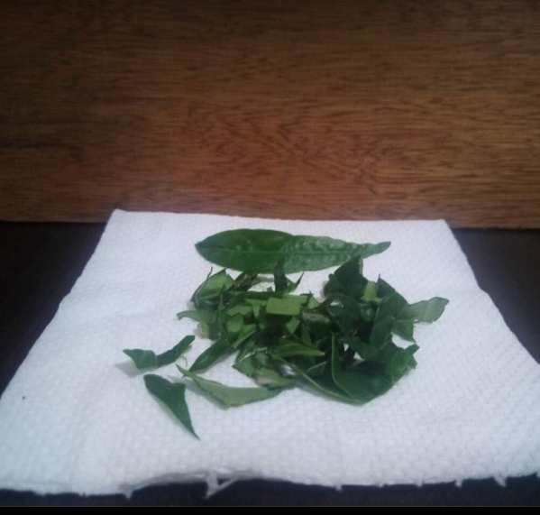 Eucalyptus |   Peppermint | 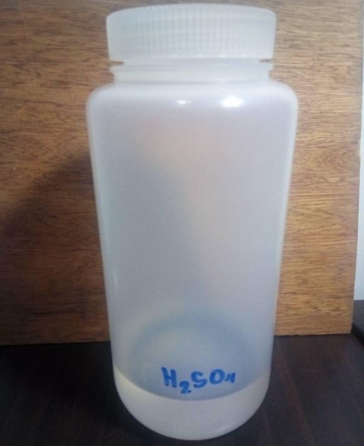  Sulfuric
Decay | 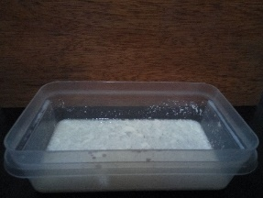  Milk | 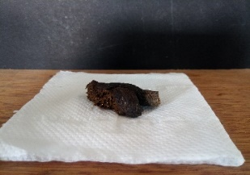  Dog Feces | 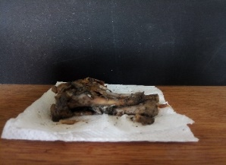  Chicken | 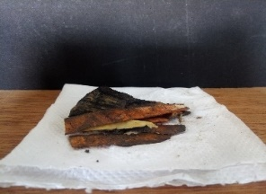  Veggies | 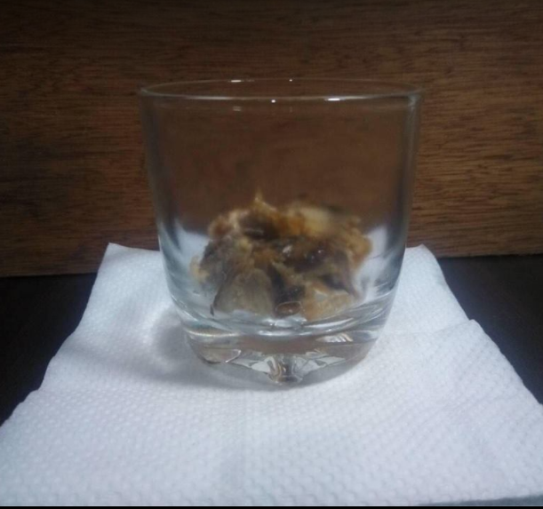  Rotten fish
 | 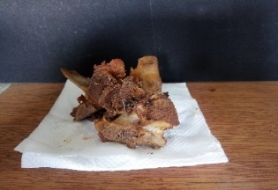  Rotten pork | 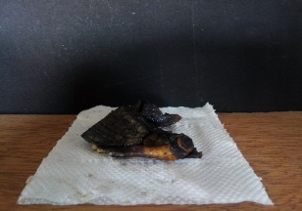  Rotten fruit | 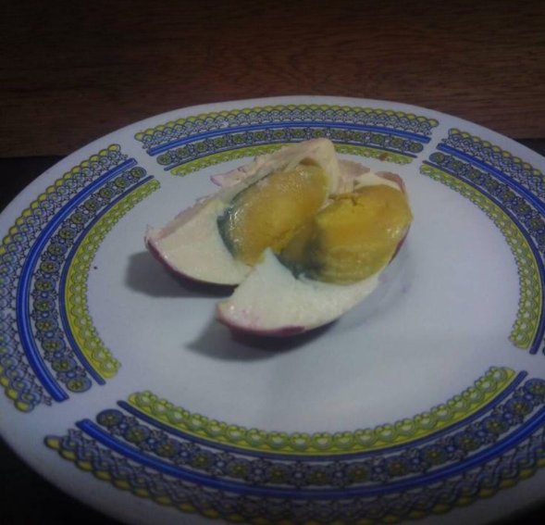  Salted egg | 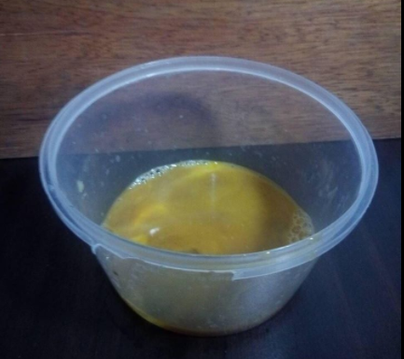  Rotten egg | 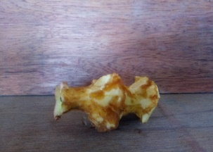  Rotten apple
Pungent | 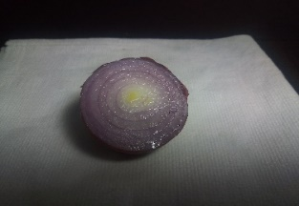  Onion | 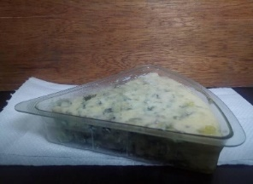  Blue Cheese |   Cigar 1 | 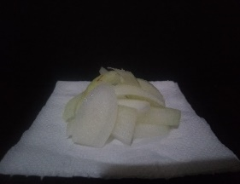  Onion 1 | 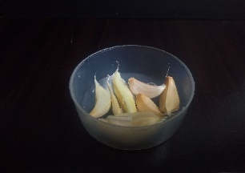  Garlic 1
 | 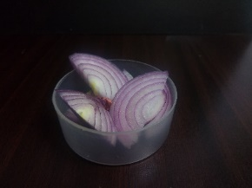  Onion |   Burnt Rubber |   Cigar 2 | 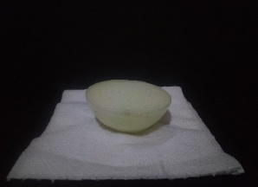  Onion 2 | 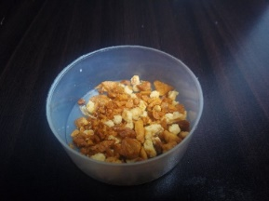  Garlic 2
Citrus | 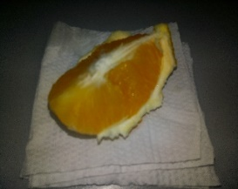  Orange | 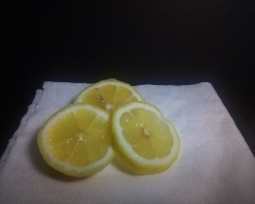  Lemon 1 | 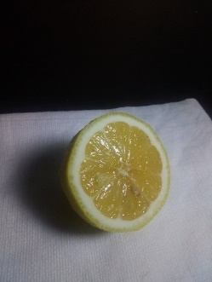  Lemon 2 | 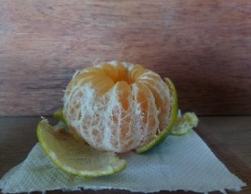  Mandarin | 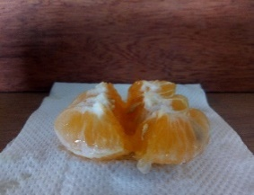  Dalandan
 | 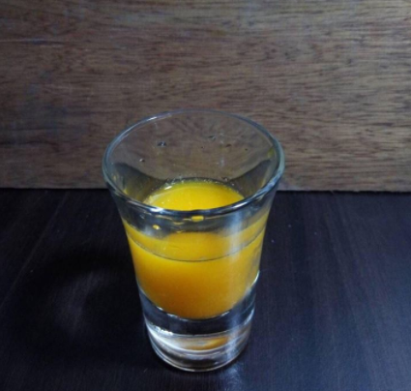  Juice | 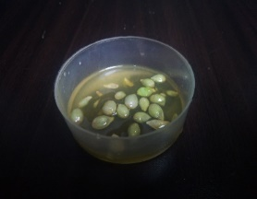  Extract | 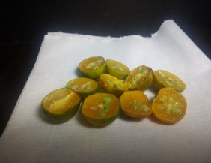  Calamansi | 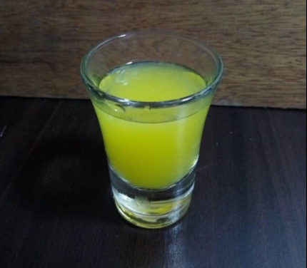  Pineapple | 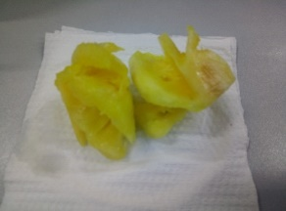  Pineapple
Popcorn | 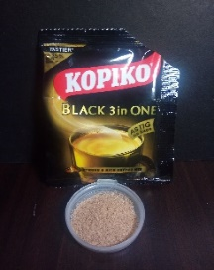  Coffee |   Coffee | 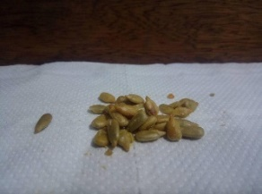  Peanuts 1 | 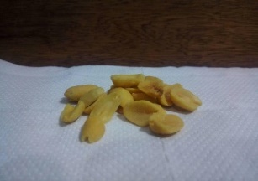  Peanuts 2 | 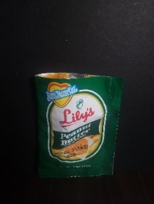  Spread
 | 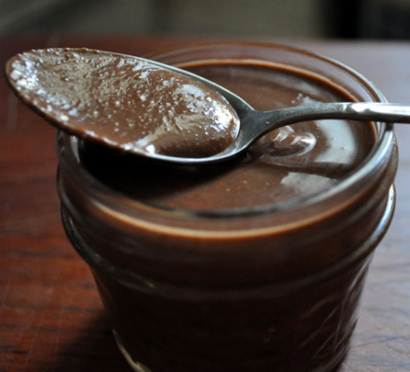  Spread | 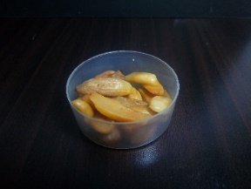  Pili nuts | 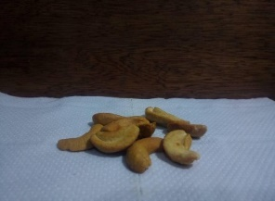  Cashew | 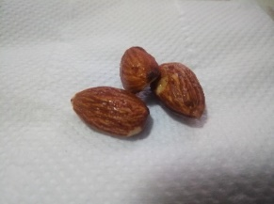  Almonds | 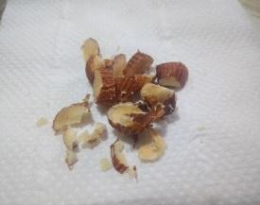  Nuts
Sweet | 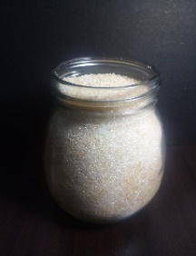  Sugar 1 | 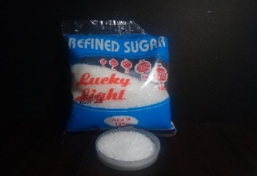  Sugar 2 | 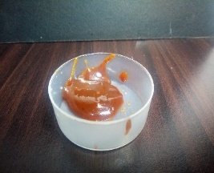  Jam | 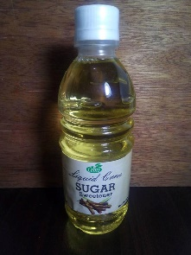  Honey | 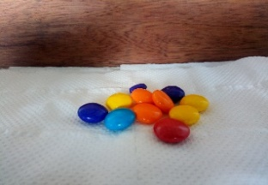  Chocolate 1
 | 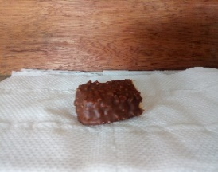Chocolate 2 | 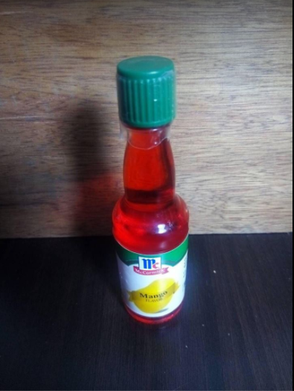  Vanilla 1 | 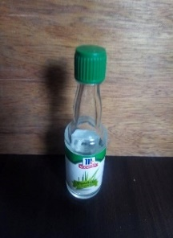  Vanilla 2 | 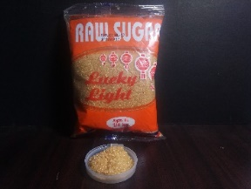  B. Sugar 1 | 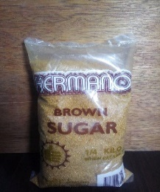  B. Sugar 2

Table II Final Ann Confusion Matrix
S | Fragrant | Woody | Fruity | Chemical | Minty | Decaying | Pungent | Citrus | Popcorn | Sweet
1 | 144 | 5 | 1 | 0 | 0 | 0 | 0 | 0 | 0 | 0
2 | 13 | 124 | 1 | 0 | 12 | 0 | 0 | 0 | 0 | 0
3 | 2 | 0 | 147 | 1 | 0 | 0 | 0 | 0 | 0 | 0
4 | 0 | 1 | 0 | 149 | 0 | 0 | 0 | 0 | 0 | 0
5 | 0 | 0 | 0 | 0 | 148 | 0 | 2 | 0 | 0 | 0
6 | 0 | 0 | 0 | 0 | 0 | 71 | 6 | 44 | 17 | 12
7 | 0 | 0 | 0 | 0 | 28 | 4 | 83 | 0 | 24 | 11
8 | 0 | 28 | 1 | 0 | 2 | 17 | 0 | 102 | 0 | 0
9 | 0 | 0 | 0 | 0 | 0 | 0 | 1 | 0 | 136 | 13
10 | 0 | 0 | 0 | 0 | 0 | 4 | 28 | 0 | 30 | 88

Table III Class Precision, Recall and F-Measure for the Different Odor Classes
Class | Precision | Recall | F-measure
Fragrant | 0.960000000 | 0.905660377 | 0.932038835
Woody | 0.826666667 | 0.784810127 | 0.805194805
Fruity | 0.980000000 | 0.980000000 | 0.980000000
Chemical | 0.993333333 | 0.993333333 | 0.993333333
Peppermint | 0.986666667 | 0.778947368 | 0.870588235
Decaying | 0.473333333 | 0.739583333 | 0.577235772
Pungent | 0.553333333 | 0.691666667 | 0.614814815
Citrus | 0.680000000 | 0.698630137 | 0.689189189
Popcorn | 0.906666667 | 0.657004831 | 0.761904762
Sweet | 0.586666667 | 0.709677419 | 0.642335766

Table IV Mean Sensor Measurement per Odor Class
S | Fragrant | Woody | Fruity | Chemical | Minty | Decaying | Pungent | Citrus | Popcorn | Sweet
1 | 302.9 | 277.3 | 369.0 | 347.3 | 277.4 | 277.3 | 266.8 | 282.9 | 259.2 | 260.9
2 | 155.5 | 170.4 | 175.7 | 223.8 | 171.7 | 170.4 | 171.7 | 172.1 | 171.9 | 172.5
3 | 200.7 | 203.2 | 231.1 | 323.9 | 226.8 | 223.2 | 220.5 | 211.6 | 217.9 | 216.7
4 | 170.4 | 174.3 | 188.5 | 243.7 | 190.1 | 174.3 | 185.1 | 178.2 | 176.3 | 182.1
5 | 111.6 | 128.3 | 106.3 | 130.8 | 135.3 | 128.3 | 137.1 | 119.4 | 138.7 | 137.1
6 | 244.8 | 260.3 | 281.8 | 372.6 | 270.2 | 260.3 | 264.3 | 260.2 | 261.0 | 264.5
7 | 199.0 | 201.5 | 217.8 | 267.0 | 220.3 | 201.5 | 211.0 | 202.4 | 206.5 | 206.1
8 | 211.8 | 207.9 | 224.3 | 329.4 | 234.3 | 237.9 | 232.1 | 228.3 | 210.9 | 202.5
9 | 124.7 | 137.3 | 139.0 | 171.5 | 142.0 | 137.3 | 138.4 | 138.6 | 140.7 | 139.6
10 | 311.4 | 352.3 | 352.5 | 354.0 | 354.2 | 352.3 | 354.4 | 352.9 | 353.9 | 354.2

It can be noticed from Table IV that the classes with relatively inferior results (decaying, pungent, citrus, sweet) have several sensors with comparatively close measurements. For instance, about 12% of decaying samples were incorrectly classified as citrus, and this could be due to several sensor readings within close range (MQ3, MQ7, MQ8, MQ135, MQ138). The MQ-series gas sensors have partial sensitivity, i.e., that they can respond marginally to a range of gases, as listed in table Table V. MQ8 could marginally respond to alcohol and LPG, MQ135 has small sensitivity to ammonia etc.
Table V Sensor Sensitivity
Sensor | High Sensitivity | Partial Sensitivity
MQ 2 | Smoke | LPG, propane, hydrogen
MQ 3 | Alcohol
MQ 4 | Natural gas | Methane (CH4)
MQ 5 | LPG | Natural gas
MQ 6 | Butane, Propane | LPG, Natural gas
MQ 7 | Carbon Monoxide
MQ 8 | Hydrogen Gas | Alcohol, LPG
MQ 9 | Methane | Propane and CO
MQ 135 | Benzene | Ammonia
MQ 138 | Ammonia

