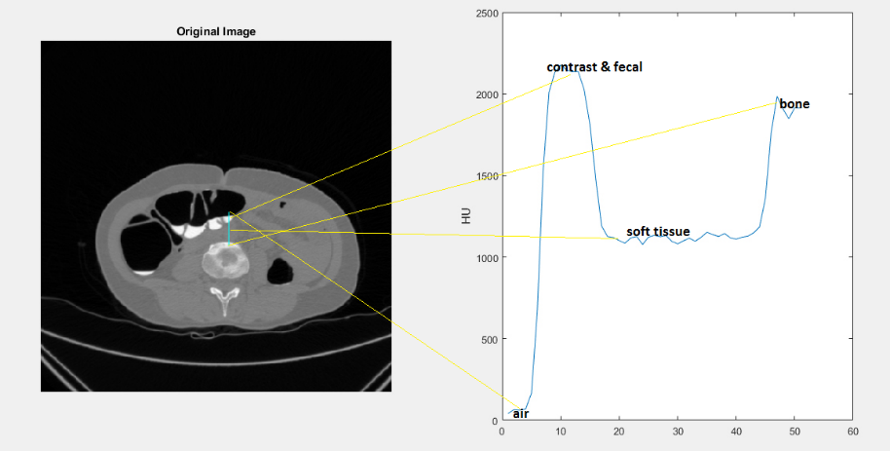

Fig. 5. HU range for air, residual material, soft tissue and bone