A novel approach for segmentation of Brain Image using a Multiscale transform and a region based Active contour.
Mrs.Smitha P
Research Scholar, Dept of Electronics and Communication,BMSCE,Basavanagudi,Bengaluru-19
smithap.ullal@gmail.com

Dr.Nanjraj C P
Professor & Head, Dept of Radiodiagnosis, MMC & RI,Mysore
nanjraj@yahoo.co.in

Dr.Meera A
Professor, Dept of Electronics and Communication, BMSCE, Basavanagudi,Bengaluru-19
amira.ece@bmsce.ac.in
Abstract:
Over the Past decade Medical Image segmentation is one of the most challenging and focused topic for intensive research in interdisciplinary areas of Image processing and computer vision. Segmentation is the process of automatic or semi-automatic detection of boundaries [5]. In this paper, we implement a novel unsupervised method for segmenting MRI brain Images based on multiresolution transforms and region based active contour. Application of multiscale, multiresolution methods with active contour is most interesting research topic in image segmentation [6].This new application makes segmentation algorithms more economical for computation.
Keywords: Multiscale and Multiresolution Transform, Chanvese active contour, Curvelet transform
1. Introduction
Segmentation is a fundamental operation on Medical image Analysis. Segmentation effectively partitions the image into homogeneous (segments) groups of common feature vectors that comprises gray levels, motion, texture etc. Boundary detection is an integral part of this process since it helps to identify the individual segments themselves. In this paper we propose an integrated segmentation approach that combines a gradient based Active contour method and multiscale Curvelet transform which is a sparsifying transform method to resolve the problem of intensity inhomogenity of Medical images, to reduce the computational cost and enhance the search for the global minimum. This proposed method promises to recognize weak edges and strong noises. This method was developed based on the inspired ideas of multiresolution wavelet transform hybrid with Active contour approaches. Curvelet is multidirectional, multiscale geometric wavelet transform [21]. Curvelet transform is relatively new multiresolution [20] analysis technique for sparse coding [optimal sparse representation [23] of objects and edges]. Curvelet produces the edge map of objects by Curvelet thresholding instead of simple gradient methods. In addition to this we also use the Mumford-Shah model based Chanvese active contour method for efficient image segmentation [22]. The Chanvese active contour is also a geometric active contour. Region based active contour model (ACM) utilizes the objective and the background regions statistically to find optimum energy. Due to which advantages over edge based ACMs, Region based ACMs are more popular for their robustness for image with weak edges or without edges. The Chanvese (CV) model is one of the most popular region based models [10]. In this paper we use a region based active contour method which ignores edges completely (“Active Contours without Edges” method by Chan and Vese [23]). Active contour models (ACMs) based segmentation methods have gained popularity due to their sub pixel accuracy as they provide closed and smooth edges.

2. Literature Survey
Curvelet transform is typically applicable in Medical image analysis for detecting intrinsic geometric curve like structures that forms a large portion of the medical images [15].Curvelet transform was initially introduced by Candes and Donoho[16]. Curvelet transform decompose the image into sub bands and separate the object into a series of disjoint scales. Curvelet thresholding is implemented for denoising[17,18,19], which proves efficient than gradient methods for recognize edges weak edges and as well as strong noises. A higher Curvelet coefficient corresponds to a stronger edge and the noise corresponds to a smaller coefficient. So by choosing Proper threshold, we retain the bigger coefficient and abandon the smaller coefficient to achieve the image denoising. Active contours are a catch-all name for methods that find the curve that best separates objects in an image. This is known as segmentation [1]. The concept of Active contour (AC) models for segmentation the original model were initially proposed by Kass et al[13].This classical approach drives an initial contour towards the boundaries of the objects by minimizing an energy function whose minimum is obtained at the boundaries of the object(s). Chanvese active contours [26] establish the most robust and efficient method of image segmentation than the classical methods of histogram, thresholding, gradient based methods etc. Chanvese method of segmentation is a special case of Mumford-Shah functional model. This method of segmentation is used widely in the medical imaging field, especially for the segmentation of the liver, brain, heart etc [29].The Chanvese model solves problems of curve evolution in the parametric active contour model and extends the application region of the active contour model. Chanvese [CV] model, also known as PC (piecewise constant) model, proposed in [25], is a simplified Mumford-Shah function. The model utilizes the global mean intensities of the interior and exterior regions of images. Thus, it has good segmentation result for the objects with weak or discrete boundaries but often has erroneous segmentation for images with intensity inhomogeneity. However, due to technical limitations or artifacts introduced by the object being imaged, intensity inhomogeneity often occurs in many medical images [31].
In section5 the level set formulation of the Chan-Vese model is described using a semi-implicit gradient descent.
Some of the limitations of Active contours are stated as follows:
1) The main drawback of these classical and traditional active contour models is that it depends on curve parameters, which cannot handle topology changes of the curve(s) automatically.
2) The curve evolution speed is very slow, as a result convergence is also slow and the level set formulation requires reinitialization at every step during evolution.
3) AC method has a great sensitivity to noise which may yield false segmentation results. Meanwhile, for noise images, the gradient descent flow requires much more expensive computation and iterations to force the active curve(s) to converge.

Combining a multiscale, multiresolution transform such as Curvelet transform with Active contour models can effectively and intuitively solve those problems of Noise inhomogenity [13]. Firstly, with the coarse-to-fine scale and small-to-big size strategies, the Activecontour models cost less expensive for computation because the rough segmentation results of the coarse scale maps can be taken as the initial contour of the following scale map. The multi-resolution strategy has more robust and strong ability to reduce the effect caused by noise [14].Wu et al., (2000) [2] proposed a directional image force for active contours based on wavelet frames. The wavelet-based snakes are helpful for noise suppression. Mignotte and Meunier (2001),[3]presented a multiscale approach for deformable contour optimization relying on a multigrid coarse-to-fine relaxation algorithm. Liu and Hwang (2003),[8]proposed an integrated wavelet-based snake model for segmentation and tracking based on the coarse-to-fine strategy. Bresson et al., (2006)[9] applied linear scale space into the parametric snake model. In this paper a Curvelet transform based geometric active contour is proposed for image segmentation of multiple objects. Curvelet denoising [17, 18] with proper threshold is superior to gradient methods as it promisingly recognize the weak edges and robust for strong noises. Alvino et al., [2005] have proposed a research thesis on novel multiscale active contour methods to several problems in computer vision, especially in simultaneous segmentation and reconstruction of tomography images [10].Multiscale image transforms like wavelets provide a directional image force for active contours, applying multiscale methods to snakes is one of the hot topics in image segmentation [11].

3. Methodology
3.1. Curvelet Multiscale transform for Image segmentation
FDCT can be implemented in two ways. First method is based on unequally spaced fast Fourier transform (USFFT) and the second is based on the Wrapping of specially selected Fourier samples. Both FDCT’s differ by spatial grid used to translate Curvelet at each scale and angle and both FDCTs run in O (n2 log n).It is efficient for those images that display curve punctuated smoothness.
Fast Discrete Curvelet transform (FDCT) [24] takes as input a Cartesian grid of the form 0 , and outputs a collection of coefficients C^{D} ( j, l, k) defined by where are digital Curvelet waveforms which preserve the listed properties of the continuous curvelet.
For a Cartesian array f[] , where 0≤n≤ and 0≤n≤ and are dimensions of the array collection.
Curvelet coefficients C^{D} (j,l,k) indexed by a scale j, an orientation l and spatial location parameters k and is given by
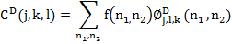
is the digital curvelet waveform. Eqn [1] This is a part of Reiz representation.
Curvelet transform = IFFT [FFT (Curvelet) x FFT (Image)], and the product from the multiplication is a wedge.
Fast discrete curvelet transform via frequency wrapping is obtained from the following steps:
1. Apply the 2D fast Fourier transform (FFT) and obtain Fourier samples ƒ^ [n1,n2], where −n/2 ≤n1, n2< n/2.
2. For each scale j and angle l obtain Ũj, ℓ [n1, n2] ƒ^ [n1, n2] by forming the product with Cartesian window
3. Wrap this product around the origin ƒ`j,ℓ[n1, n2]=W(Ũj,ℓƒ^)[n1,n2] where the range for n1 and n2 is now 0 ≤ n1< L1,j and 0 ≤n2< L2,j and θ in the range (- π/4 , π/4 ).
4. Apply the inverse 2D FFT to each and hence collecting the discrete coefficients ƒ`j,ℓ hence collecting the discrete coefficients CD(j, ℓ, k)[1].The software package CurveLab is used in implementing the Curvelet transform.
3.2. Mumford and Shah Minimization problem
The Mumford–Shah functional is a functional that is used to establish an optimality criterion for segmenting an image into sub-regions. An image is modeled as a piecewise-smooth function. The functional penalizes the distance between the model and the input image, by minimizing the functional one may compute the best image segmentation. The functional was proposed by mathematicians David Mumford and Jayant Shah in 1989[27].The Mumford-Shah model is an important variational image segmentation model. A popular multiphase level set approach, the Chan-Vese model [25, 30], was developed for this model by representing the phases by several overlapping level set functions. ChanVese approach involves geometric active contour model (based upon Mumford -Shah Functional). The model begins with a contour in the image plane defining an initial segmentation and then contour is evolved according to evolution equation. The basis of Chanvese algorithm is a Fitting Energy Functional [26, 28]. The goal of algorithm is to minimize this fitting energy for a given image and corresponding will define segmentation.
For any given image a decomposition of and an optimal piecewise smooth approximation such that varies smoothly within each and rapidly or discontinuously across the boundaries of
To solve this problem, Mumford and Shah (1989) proposed the following minimization problem;
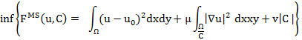
A reduced case of the model is obtained by restricting the segmented image to piecewise constant function, i.e.
Inside each connected component .This problem is called “Minimal Partition problem” and its functional is
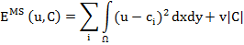
It is easy to see that, for a fixed , the energy from above is minimized in the variables by setting
3.2.1. Levelset curve formulation [Lipschitz function]:Ω→R
The Levelset curve evolution is explained in [29],
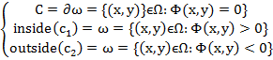
Thus
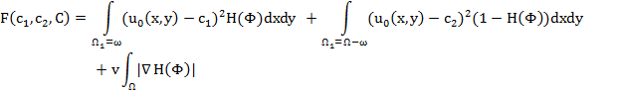
Where is Heaviside function and is the input image. This minimization problem is solved by taking the Euler-Lagrange equations and updating the level set.
In order to reach the minimum of F, we find the derivatives of F and set them to zero
From Euler-lagrange equation we therefore update and Φ recursively.

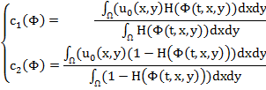
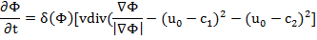
Where is the Dirac function.
3.2.2. The Chanvese active contour without edges
By the Mumford Functional for “Minimal partition problem”
and by the given curve , with an open subset, and two unknown constants and ,denoting ,. Chanvese proposed to minimize the energy with respect to
to detect objects in a given image based on techniques of curve evolution, Mumford–Shah functional for segmentation and level sets.
8. Our Proposed method
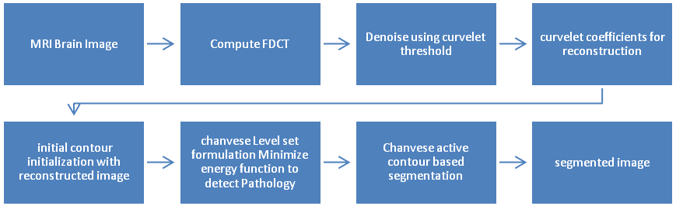
To extract the desired regions of interest [ROI], the proposed algorithm operates by decomposing the enhanced image into different frequency bands. The Fast Discrete Curvelet Transform (FDCT) is applied this allows a sparse representation of objects in an image. With proper threshold, Curvelet denoising is performed on the image. The image is then reconstructed with curvelet coefficients after threshold and denoising. Thus this reconstructed Curvelet output image is used to initialize the Chanvese region based active contour model. We used the two phases and multiphase Chanvese active contour model that utilizes the global mean intensities of the interior and exterior regions of images, and provide good segmentation for the objects with weak or discrete boundaries.
4. Results
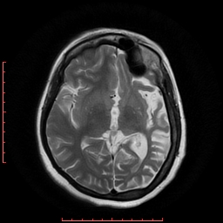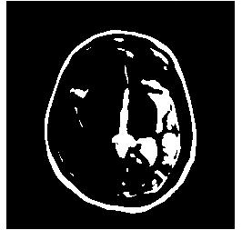
Fig 4.1) Brain MRI Image Fig 4.2)Curvelet denoised and fused output image
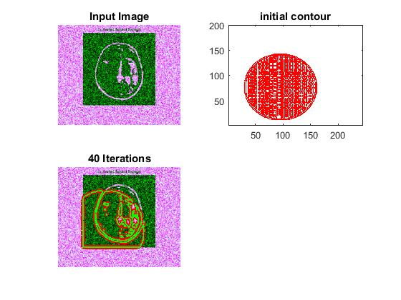

Fig 4.3) Chanvese active contour segmentation initialized with Curvelet output

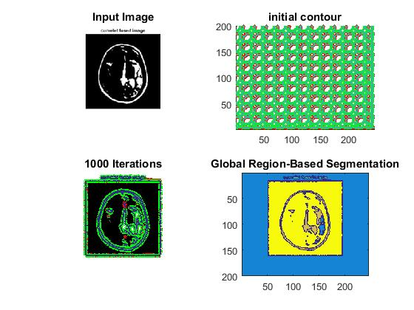
Fig 4.4) Integrated Multiscale and region based segmentation output.
Fig 4.1 shows the MRI image of human brain, which is then, analyzed using multiscale and multiresolution strategies using Curvelet transform. The Curvelet coefficients with suitable thresholding are reconstructed and denoised to produce the output image in Fig 4.2. The output image in Fig 4.2 is then initialized and segmented using Chanvese active contour in two phases, with noise removal at intermediate stages Fig 4.3. Finally we get the segmented output as shown Fig 4.4 which shows the Pathological region highlighted in bluish patch, the segmented output.
5. Discussion and Conclusion
Application of Multiscale methods with Active contour model for image segmentation is an active research area. In this paper a combination of Multiscale Curvelet transform and Chanvese region based active contour is proposed for detecting the desired ROI from MRI Brain Images. The Curvelet transform is a multi scale transform with better directional sensitivity .It helps to extract the image detail at various scales and directions according to the features of interest to be extracted. Integrating a multiscale , multiresolution transform such as Curvelet transform with Active contour models can effectively and intuitively solve those problems of Noise inhomogenity [13].The proposed Multiscale active contour segmentation model uses the entire scale space, to introduce the geometry of multiscale images in the segmentation process. The extracted multiscale structures will efficiently improve the robustness and the performance of standard shape analysis segmentation techniques such as shape recognition and shape registration and is able to extract convex and concave object based on coarse-to-fine scale and small-to-big size strategies. The active contour models cost less expensive for computation because the rough segmentation results of the coarse scale maps can be taken as the initial contour scale map. The multi-resolution strategy is more robust to reduce the effect caused by noise. The segmented images show improved accuracy and precision. Further the research is open to implement other variational levelset Active contours for efficient segmentation.

6. References

- Liu, Zhigui, Junbo Wang, and Yuyu Zhu. "A study of active contour segmentation models based on automatic initial contour." International Journal of Signal Processing, Image Processing and Pattern Recognition 8.4 (2015): 201-214.

- Wu, H., Liu, J., Chui, C., 2000. A wavelet-frame based image force model for Active
contouring algorithms. IEEE Trans. Image Process. 9 (11), 1983–1988.

- Mignotte, M., Meunier, J., 2001. A multiscale optimization approach for the dynamic
contour-based boundary detection issue. Comput. Med. Imaging Graph. 25 (3),
265–275.

- Singh R& Khare, A. (2013). Multiscale medical image fusion in wavelet domain. The Scientific World Journal, 2013

- Ali, Rehan, et al. "Semi-automatic segmentation of subcutaneous tumors from micro-computed tomography images." Physics in medicine and biology 58.22 (2013): 8007.

- Shan, Hao, and Jianwei Ma. "Curvelet-based geodesic snakes for image segmentation with multiple objects." Pattern Recognition Letters 31.5 (2010): 355-360.

- Wang, Guodong, et al. "Unsupervised texture segmentation using active contour model and oscillating information." Journal of Applied Mathematics 2014 (2014).

- Li, Ling, et al. "Multiscale Geometric Active Contour Model and Boundary Extraction in Kidney MR Images." International Conference on Health Information Science. Springer, Cham, 2014.

- Bresson, Xavier, Pierre Vandergheynst, and Jean-Philippe Thiran. "Multiscale active contours." International Journal of Computer Vision 70.3 (2006): 197-211.

- Alvino, C. V. (2005). Multiscale active contour methods in computer vision with applications in tomography (Doctoral dissertation, Georgia Institute of Technology).

- Al-Qunaieer, Fares S., Hamid R. Tizhoosh, and Shahryar Rahnamayan. "Multi-resolution level set image segmentation using wavelets." Image Processing (ICIP), 2011 18th IEEE International Conference on. IEEE, 2011.

- Kass, Michael, Andrew Witkin, and Demetri Terzopoulos. "Snakes: Active contour models." International journal of computer vision 1.4 (1988): 321-331.

- Chen, Da, Dengwang Li, and Mingqiang Yang. "Active contour for noisy image segmentation based on contourlet transform." Journal of Electronic Imaging 21.1 (2012): 013009-1.

- Law, Yan Nei, Hwee Kuan Lee, and Andy M. Yip. "A multiresolution stochastic level set method for Mumford–Shah image segmentation." IEEE transactions on image processing 17.12 (2008): 2289-2300.

- Kalavathi, P., and T. Priya. "Segmentation of Brain Tissue in MR Brain Image using Wavelet Based Image Fusion with Clustering Technique."

- J. L. Starch , E. J Candes , D. L. Donoho ,“The Curvelet Transform for Image Denoising” , IEEE Trans on Image Processing, vol . 11 , Issue 6 , pp 670 – 684 , 2002

- Starck, Jean-Luc, Emmanuel J. Candès, and David L. Donoho. "The Curvelet transform for image denoising." IEEE Transactions on image processing 11.6 (2002): 670-684.

- Singh, Rajat, and D. S. Meena. "Image Denoising Using Curvelet Transform." Department of Computer Science and Engineering National Institute of Technology, Rourkela.

- Aili, Wang, et al. "Image denoising method based on curvelet transform." Industrial Electronics and Applications, 2008. ICIEA 2008. 3rd IEEE Conference on. IEEE, 2008.

- Ma, Jianwei, and Gerlind Plonka. "Computing with curvelets: from image processing to turbulent flows." Computing in Science & Engineering 11.2 (2009): 72-80.

- AlZubi, Shadi, Naveed Islam, and Maysam Abbod. "Multiresolution analysis using wavelet, ridgelet, and curvelet transforms for medical image segmentation." Journal of Biomedical Imaging 2011 (2011): 4.

- Dettori, Lucia, and Lindsay Semler. "A comparison of wavelet, Ridgelet, and Curvelet-based Texture classification algorithms in computed tomography." Computers in biology and medicine 37.4 (2007): 486-498.

- Candès, Emmanuel J., and Franck Guo. "New Multiscale Transforms, minimum total variation synthesis: Applications to edge-preserving image reconstruction." Signal Processing 82.11 (2002): 1519-1543.
- Emmanuel Candes, Laurent Demanet, David Donoho and Lexing Ying, “Fast Discrete Curvelet Transforms”, ACM, March 2006

- Chan, Tony F., B. Yezrielev Sandberg, and Luminita A. Vese. "Active contours without edges for vector-valued images." Journal of Visual Communication and Image Representation 11.2 (2000): 130-141.

- Chan, Tony F., and Luminita A. Vese. "Active contours without edges." IEEE Transactions on image processing 10.2 (2001): 266-277.

- Mumford, D. and J. Shah, 1989. Optimal approximations by piecewise smooth functions and associated variational problems. Commun. Pure Applied Math., 42: 577-685.

- Williams, Donna J., and Mubarak Shah. "A fast algorithm for active contours and curvature estimation." CVGIP: Image understanding 55.1 (1992): 14-26.

- Osher, Stanley, and Ronald P. Fedkiw. "Level set methods: an overview and some recent results." Journal of Computational physics 169.2 (2001): 463-502.

- Gobbino, Massimo. "Finite difference approximation of the Mumford‐Shah functional." Communications on pure and applied mathematics 51.2 (1998): 197-228.

- Vese, Luminita A., and Tony F. Chan. "A multiphase level set framework for image segmentation using the Mumford and Shah model." International journal of computer vision 50.3 (2002): 271-293.

- Bresson, Xavier, Pierre Vandergheynst, and Jean-Philippe Thiran. "Multiscale active contours." International Journal of Computer Vision 70.3 (2006): 197-211.

