

Fig.1: Threshold selection for the test image for the proposed TSTM for malaria parasite segmentation.

|  |  |  |  |  |  |  |  |  |  |  |  |  |  |  |  |  |  |  |  |  |  |  |
| --- | --- | --- | --- | --- | --- | --- | --- | --- | --- | --- | --- | --- | --- | --- | --- | --- | --- | --- | --- | --- | --- | --- |
|  |  |  |  |  |  |  |  |  |  |  |  |  |  |  |  |  |  |  |  |  |  |  |
|  |  |  |  |  |  |  |  |  |  |  |  |  |  |  |  |  |  |
|  |  |  |  |  |  |  |  |  |  |  |  |  |  |  |  |  |  |

|  |  |  |  |  |  |  |  |  |  |  |  |  |  |  |  |  |  |  |  |  |  |  |
| --- | --- | --- | --- | --- | --- | --- | --- | --- | --- | --- | --- | --- | --- | --- | --- | --- | --- | --- | --- | --- | --- | --- |
|  |  |  |  |  |  |  |  |  |  |  |  |  |  |  |  |  |  |  |  |  |  |  |
|  |  |  |  |  |  |  |  |  |  |  |  |  |  |  |  |  |  |
|  |  |  |  |  |  |  |  |  |  |  |  |  |  |  |  |  |  |

|  |  |  |  |  |  |  |  |  |  |  |  |  |  |  |  |  |  |  |  |  |  |  |
| --- | --- | --- | --- | --- | --- | --- | --- | --- | --- | --- | --- | --- | --- | --- | --- | --- | --- | --- | --- | --- | --- | --- |
|  |  |  |  |  |  |  |  |  |  |  |  |  |  |  |  |  |  |  |  |  |  |  |
|  |  |  |  |  |  |  |  |  |  |  |  |  |  |  |  |  |  |
|  |  |  |  |  |  |  |  |  |  |  |  |  |  |  |  |  |  |

Fig.2: Different Masks used in the erosion operation.

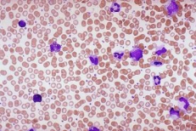 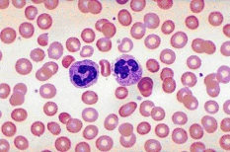 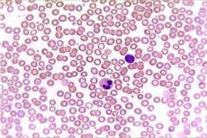

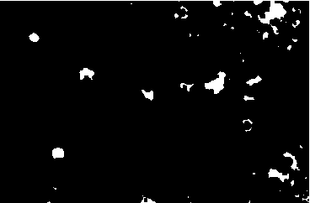 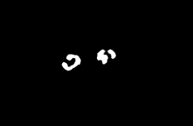 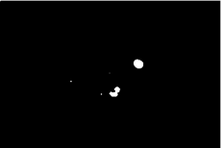

Fig.3: Segmentation of malaria parasite infected cells by proposed method: First row indicates original microscopic malaria infected images and second row represents malaria parasite infected cells extraction.

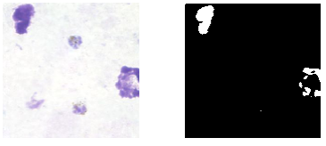

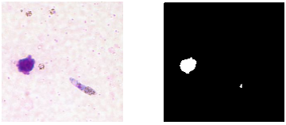

Fig.4: Malaria parasites extraction results in thick blood smear images.

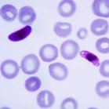  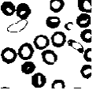 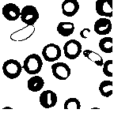

1. (b) (c) (d)

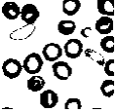 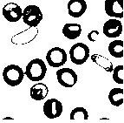 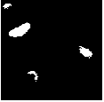 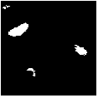

(e) (f) (g) (h)

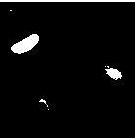 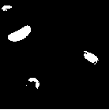 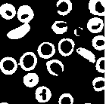 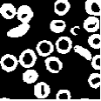

1. (j) (k) (l)

Fig. 5: Segmentation results for various values of $α$ for malaria microscopicy image: (a) Original, (b) ground truth image, (c)–(l) proposed thresholding results for different values of $β$ with $β=$ 0.1, 0.2, 0.3, 0.4, 0.5, 0.6, 0.7, 0.8, 0.9, and 1.0, respectively.