Online Learning meets Mixed-Reality Immersive Spaces: Result Increased Learning

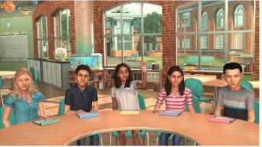
Mursion’s middle grades avatars used in the focus group interview.
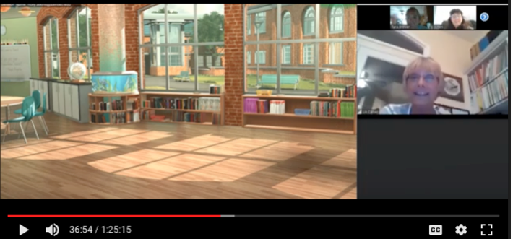

Dr. Lin Carver begins session with student participants.

