Linking of taxpayer awareness to taxpayer compliance: The moderating role of account representative employee’s performance

¹Gunawan, ²Syamsul Ridjal, ³Hisnol Jamali
¹The Master of Management Degree in School of Economics and Management STIEM Bongaya Makassar, Indonesia
²Professor of Management Science, School of Economics and Management STIEM Bongaya Makassar, Indonesia
³Associate Professor of Accounting, School of Economics and Management STIEM Bongaya Makassar, Indonesia

ABSTRACT
The purpose of this paper is to suggest and empirically test a model that explains the linking of taxpayer awareness on taxpayer compliance. In this model, account representative employee’s performance as a moderator variable. A valid research instrument was utilized to conduct a survey of 100 individual taxpayers registered in Tax Offices (KPP) Pratama North Makassar (Indonesia). The model was tested by using the partial least squares (PLS) structural equation modeling technique on the software WarpPLS, version 5.0. A thorough analysis of the role of moderator was carried out. Findings provide support for the proposed model and show that taxpayer compliance depend on taxpayer awareness as well as account representative employee’s performance level. These relationships are moderated by account representative employee’s performance. The model exhibits the highest predictive power when the account representative employee’s performance is also high. The findings may be utilized by Indonesian government and tax practitioners interested in to improvement the taxpayer compliance.

Keywords: Taxpayer awareness, compliance, account representative employee’s performance

Introduction

Contribution of the tax sector in Indonesia in financing State budget (APBN) is very dominant in terms of state revenue so important the role of tax, the government in this case the Directorate General of Taxation has made various efforts to maximize revenues tax. One of the efforts made is through the reform of legislation in the field of taxation with the enactment of self assessment system that requires taxpayers to fulfill their tax obligations, namely to fill out and submit the Notice (SPT) in the Tax Office. High awareness and compliance from the taxpayer is an important factor in the implementation of the system (Herryanto & Toly, 2013).
Self assessment system demands the active participation of the community in fulfilling the tax obligations (Trisnayanti & Jati, 2015). The self-assessment carries the mission and consequences of changing people's attitude (consciousness) to voluntary compliance. Compliance with voluntary tax obligations is the backbone of the self assessment system (Waluyo & Wirawan, 2011). The phenomenon that occurred in the world of taxation Indonesia lately makes people and taxpayers worried to pay taxes. Such conditions may affect taxpayer compliance, as taxpayers do not want the tax already paid to be misused by the tax authorities themselves. Therefore, some communities and taxpayers are trying to avoid taxes. Taxpayer awareness (TA) of the tax function as state financing is needed to improve taxpayer compliance (TC) (Diana, 2013). The public must be aware of its existence as a citizen and must always uphold the 1945 Constitution as the legal basis of state administration (Arum, 2012).
Taxpayers' awareness (TA) to pay taxes can be interpreted as an awareness that taxes are a form of participation in supporting state development and / or awareness that delaying tax payments and reducing tax burdens are detrimental to the state and awareness that taxes are established by law and can be imposed (Mardiasmo, 2011: 87). Previous research evidence shows that tax awareness has a significant positive effect on taxpayer compliance (Dewi & Merkusiwati, 2018; Kesumasari & Suardana, 2018; Purba, 2018). These results are different from the findings of other researchers, that consciousness is not significant effect on taxpayer compliance. This means the taxpayer considers that the obligation in paying taxes has no direct added value to him (Hidayati, 2014; Nugroho et al., 2016; Ndona, 2018).
High or low the level of taxpayer compliance is not only influenced by the taxpayer awareness factor, but there are other factors that are external factors indicated by the account representative employee’s performance. Account representative is a liaison partner between the Directorate General of Taxes and the taxpayer. Duties and obligations of employee’s account representative performance (ARP) namely; supervising taxpayer compliance, compiling taxpayer profile, and taxpayer performance analysis, taxpayer data reconciliation in the framework of intensification and evaluating the result of appeal based on applicable provisions (Regulation of the Minister of Finance Number 162 / PMK.011 / 2012).
The receipts of individual tax for the year 2016 experienced a very high increase, when compared with previous years. The high increase motivates the researcher to do this research so that this research is done with the intention to test and analyze whether the increase is caused by tax awareness owned by taxpayer which is higher or due to account representative employee’s performance directly and or whether the increase happened because it is reinforced by the role of account representative employee’s performance as a supporting of taxpayer awareness. Improving the taxpayer compliance is to provide good service to the taxpayer, especially an account representative employee’s. Improving the quality and quantity of service is expected to increase the satisfaction to the taxpayer as the customer so as to increase compliance in the field of taxation (Law No. 16 of 2009 on General Provisions and Procedures Taxation) .
The new paradigm that puts the government apparatus as servants of state and society tax) should take precedence in order to improve the performance of public services. Account representative performs supervisory duties of taxation obligations, conducts guidance and appeal to taxpayers and potential excavations (Regulation of the Director General of Tax No. PER-03 / PJ / 2013). Account representative employee’s performance as has several taxpayers who must be supervised in carrying out its tax obligations (Eddy, 2013).
The research results (Alfiansyah & Venusita, 2012; Setiawan, 2017, Ulyani, 2017) provide evidence that account representative employee’s performance has a positive and significant impact on taxpayer compliance. The evidence is different from the findings of other researchers, that the account representative employee’s performance has a positive and insignificant effect on taxpayer compliance (Muammarsyah, 2011; Ashari et al., 2017). The inconsistency of the findings is shown by Sandi (2010), the account representative employee’s performance characterized by service and supervision has a positive and significant impact on taxpayer compliance, while consultation significant to taxpayer compliance.
The theory underlying the creation of influence among the variables built in this study refers to social learning theory proposed by Bandura (1977), that the social learning theory is relevant to explain the behavior of the taxpayer in fulfilling his obligation to pay taxes. The taxpayer will be obedient to pay taxes on time, if through his direct observation and experience; the tax levies have made a real contribution to development in his territory. Taxpayers will also be tax-imposed if they have received service and supervision and consultation from account representative employee’s performance in accordance with their expectations as a manifestation of account representative employee’s performance (Ulfah, 2018).

Methods
This research is explanatory Research which attempts to explain causality relationship and to test and confirm the relationship between variables. The population in this study were 92,207 individual tax payers registered at KPP Pratama North Makassar in 2017 years, the sampling technique was performed by using simple random sampling with the support of slovin formula to obtain 100 person taxpayers on 0, 05%. To test hypotheses, we used structural equation modeling in WarpPLS 5.0 software. This is based on partial least square (PLS) and it is recommended for small-sized samples (Kock, 2011; Hasanuddin & Sjahruddin, 2017 ).

Results
After completing the process of data collection, it can to achieve the participation of 100 individual taxpayers and valid questionnaires Wet considered as are presentative sample. Grouping of respondents by sex dominated by men as many as 58 people or 58.00%, that men have a level of awareness and compliance taxation more than women. At the age of respondents characterized by age 38-44 years or 36 persons (36.00%), that they are generally in a category that is physically relatively young, so they have a high working motivation to earn income and correlate with awareness and compliance in the field of high taxation. The marriage status of respondents dominated by respondents who have been married, i.e. by 83 people or 83.00%. It can be concluded that the married taxpayer has more ability in complying with applicable taxation provisions than the taxpayer of an unmarried person.
The higher the level of individual taxpayer education, the higher the awareness and compliance it has in the field of taxation, the condition can be seen in the table above, that the respondent is dominated by the last level of education i.e. Bachelor Strata One, which is 70 people or 70.00%. For the duration of the work, the respondents are dominated by a relatively new working period of 8-14 years i.e. 41 people or 41.00%. The condition explains that the taxpayer has sufficient financial ability so that they are willing to fulfill their tax obligation in accordance with the prevailing regulations. Finally in the field of work, the respondents are an Entrepreneur that is as many as 58 or 58.00%. The results explain that in general taxpayers have the ability to comply with applicable regulations, as every transaction in the business world (employers) is generally taxed and indicated on their tax report. Table 1. presents the results concerning the respondents 'characteristics.
Table 1.Respondents' characteristics
Characteristics |  | Frequency (n=100) | Percent
Gender
 | Male | 58 | 58,0
 | Female | 42 | 42,0
Ages
 | 24 - 30 Years | 14 | 14,0
 | 31 - 37 Years | 20 | 20,0
 | 38 - 44 Years | 36 | 36,0
 | 45 - 51 Years | 21 | 21,0
 | 52 - 58 Years | 8 | 8,0
 | 59 - 65 Years | 1 | 1,0
Marital status
 | Single | 13 | 13,0
 | Married | 83 | 83,0
 | Separated/divorced/widowed | 4 | 4,0
Educational level
 | Senior High School | 8 | 8,0
 | Diploma | 12 | 12,0
 | Bachelor degree | 70 | 70,0
 | Masters programs | 10 | 10,0
Job tenure
 | 1 - 7 Years | 38 | 38,0
 | 8 - 14 Years | 41 | 41,0
 | 15 - 21 Years | 15 | 15,0
 | 22 - 28 Years | 5 | 5,0
 | 29 - 35 Years | 1 | 1,0
Profession
 | Entrepreneur | 58 | 58,0
 | Civil servants/Army/Police | 16 | 16,0
 | Private employees | 26 | 26,0

Respondents' responses to the research variables can be shown in the following table:
Table 2. Respondents, Mean Convergent validity
Variables | Measurement | Mean | Convergent validity
 |  |  | First | Final
(TA) | The Act (X₁₁) | 3,94 | 0.74 | 0.81
 | Tax function (X₁₂) | 3,54 | 0.28 | *) < 0,60
 | Taxation duties (X₁₃) | 4,13 | 0.86 | 0.86
 | State financing (X₁₄) | 4,11 | 0.55 | *) < 0,60
 | Voluntary (X₁₅) | 3,94 | 0.78 | 0.80
 | Reporting taxes (X₁₆) | 3,59 | 0.73 | 0.74
(ARP) | Service (M₁₁) | 3,66 | 0.91 | 0.95
 | Consultation (M₁₂) | 3,64 | 0.92 | 0.95
 | Control (M₁₃) | 3,47 | 0.61 | *) Indicator value < 0,60
(TC) | Understanding of taxation (Y₁₁) | 3,11 | 0.75 | 0.75
 | Filling in form (Y₁₂) | 3,52 | 0.87 | 0.87
 | Calculate tax (Y₁₃) | 3,76 | 0.93 | 0.93
 | Punctuality (Y₁₄) | 3,91 | 0.86 | 0.86
*) Unconditional if < 0.60
The average of response on average on the taxpayer awareness variable obtained value of 3.20 which means that the assessment of the respondents to the awareness of taxpayers is good enough; the most important indicator in explaining taxpayer awareness is shown through taxation liabilities with the average value of respondents of 4.13. This result explains that respondents understand their position as citizens and consequently their involvement as citizens in national development. In the final model, the taxpayer awareness variable is measured by four indicators, namely the act, taxation duties, voluntary and reporting taxes which can be used as a measure of taxpayer awareness variable because has a value of LDF = 0.739 - 0.861> 0.70 with p-value = <0.05.
The mean value of account representative employee’s performance is 3.59. These results prove that the employee’s account representative performance quite enough. The most important dimension in explaining the account representative employee’s performance is shown in the dimension service with the average score of respondents of 3.66. These results indicate the high ability of account representative employee’s performance in receiving complaints and provide information and other tax services to taxpayers who made the maximum. In the final model, account representative employee’s performance are measured by only two dimensions, namely service and consultation which can be used as a measure of account representative employee’s performance because they have the same value LDF = 0.951> 0.70 with p -value = <0.05.
The average value of taxpayer compliance variable of 3.58, this result proves that taxpayers have sufficient levels of compliance in settling taxation obligations that are their responsibility. The most important indicator in explaining taxpayer compliance is shown in the timely with the average score of respondents of 3.91, the results indicate that in general taxpayers in reporting and paying taxes, taxpayers do so in a timely manner proved with the obligation of the taxpayer to pay his tax before the specified date or time limit. In the initial model where the four indicators, namely: understanding of taxation, filling in form, calculate tax, and punctuality are still used as a measure of taxpayer compliance variable LDF value = 0.750 - 0.925 where the value is> 0.70 with p-value = <0.05. The test of composite reliability variables considered to be reliable in explaining the data of the reliability, the test can be seen in the composite reliability and Cronbach's Alpha<0.60, for that can be shown in the following table:
Table 3. Latent variable coefficients (composite reliability)
Final Model | (TA) | (ARP) | (TC) | Moderating
R-Squared |  |  | 0.534
Adj. R-Squared |  |  | 0.520
Composite Reliability | 0.879 | 0.950 | 0.913 | 0.966
Cronbach's alpha | 0.815 | 0.894 | 0.872 | 0.959
Avr. Var.Extract | 0.645 | 0.904 | 0.726 | 0.781
Full Collin. VIF | 2.960 | 6.139 | 3.065 | 1.986
Q-Squared |  |  | 0.654

Contribution of taxpayers' awareness and account representative employee’s performance to taxpayer compliance of 0,520 or 52.00% of the rest of 48.00% is influenced by other variables not analyzed. The results obtained value-relevance predictive of Q-Squared = 0.654 or 65.40%. This means the accuracy or accuracy of this research model can explain the diversity of taxpayer awareness variable to taxpayer compliance in moderation of representative account performance of 65.40%. The remaining 34.70% is explained by other variables not found in this research model. Therefore the model is said to be good or the model is said to have a good estimation value. In the end the model can be used for hypothesis testing. That is, the value of Q-Squared obtained can be said that the model formed has an accuracy or accuracy of a good model because the value is above 60%.
The value of composite reliability for taxpayer awareness variable is 0,879> 0,60 while for performance variable account representative equal to 0,950> 0,60, then for taxpayer compliance variable equal to 0,913> 0,60 and last one in moderation variable obtained from multiplication between awareness of taxpayers with account representative employee’s performance of 0.966> 0.60. Furthermore, for the value of Cronbach's Alpha on the taxpayer awareness variable of 0.815> 0.60, for account representative employee’s performance of 0.894> 0.60 while for taxpayer compliance variable obtained Cronbach's Alpha value of 0.872> 0.60 and the last on moderation variables obtained from multiplication between taxpayer consciousness with account representative employee’s performance equal to 0,959> 0,60.
In the test, it is average variance extracted (AVE) proved that taxpayer awareness has AVE value of 0.645> 0.60, account representative employee’s performance has AVE value of 0.904> 0.60, and taxpayer compliance has AVE value of 0.726> 0.60, and lastly for moderate variables AVE = 0.781> 0.60 obtained from the root interaction of taxpayer awareness variable with account representative employee’s performance. Based on these results, it can be concluded that the overall dimensions or indicators of the three latent variables used in this study, namely taxpayer awareness, account representative employee’s performance and taxpayer compliance have a reliable in explaining the variables analyzed including the effect variables interaction between taxpayer awareness with account representative employee’s performance. Discriminant validity is assessed from cross loading measurements with constructs. Its can be seen by looking at loading latent constructs, which will predict the indicator better than other constructs. If the construct correlation with the measurement principal (each indicator) is greater than the other construct size (> on the left and right sides) then discriminant validity is met.
Table 4. Discriminant Validity
Variable | Dimention /  Indicator | Loading factor value to another construct
 |  | (TA) | (ARP) | (TC) | Moderating
(TA) | X₁₁ | 0.81 > | 0.64 | 0.24 | -0.67
 | X₁₃ | 0.86 > | 0.57 | 0.37 | -0.44
 | X₁₅ | 0.81 > | 0.53 | 0.18 | -0.35
 | X₁₆ | 0.74 > | 0.67 | 0.51 | -0.69
(ARP) | M₁₁ | 0.78 | 0.95 > | 0.70 | -0.70
 | M₁₂ | 0.64 | 0.95 > | 0.76 | -0.46
(TC) | Y₁₁ | 0.08 | 0.55 | 0.75 > | 0.081
 | Y₁₂ | 0.25 | 0.60 | 0.87 > | -0.205
 | Y₁₃ | 0.49 | 0.78 | 0.93 > | -0.318
 | Y₁₄ | 0.49 | 0.67 | 0.86 > | -0.493
Moderating (Interactions) | M₁₁*X₁₁ | -0.73 | -0.67 | -0.35 | > 0.89
 | M₁₁*X₁₃ | -0.57 | -0.59 | -0.33 | > 0.95
 | M₁₁*X₁₅ | -0.50 | -0.46 | -0.06 | > 0.86
 | M₁₁*X₁₆ | -0.70 | -0.63 | -0.37 | > 0.95
 | M₁₂*X₁₁ | -0.59 | -0.51 | -0.29 | > 0.73
 | M₁₂*X₁₃ | -0.50 | -0.59 | -0.34 | > 0.91
 | M₁₂*X₁₅ | -0.53 | -0.41 | 0.00 | > 0.86
 | M₁₂*X₁₆ | -0.56 | -0.45 | -0.28 | > 0.91

The table 4 showing of the all indicators meets the criteria of discriminant validity. Taxpayer awareness, as measured by four indicators; X₁₁ = 0,806, X13 = 0.861, X₁₅ = 0.801 and X₁₆ = 0.749, the total of loading value > compared with the loading value on the same line to construct another. The account representative employee’s performance can be measured by two dimensional; M₁₁ = 0.951 and M₁₂= 0.951 both have a loading value > compared to the loading values ​​on the same line for the other constructs. The taxpayer compliance can be measured by four dimensional; Y₁₁ = 0.750, Y₁₂ = 868, Y₁₃ = 0.925 and Y₁₄ = 0.856 both have a loading value > compared to the loading values ​​on the same line for the other constructs. The condition is similar to the moderating variable which is the interaction of the taxpayer awareness with account representative employee’s performance which is denoted by M₁₁* X₁₁ = 0.890, M₁₁* X₁₃ = 0.945, M₁₁* X₁₅ = 0.856, M₁₁* X₁₆ = 0.948 and M₁₂* X11 = 0.729, M₁₂* X₁₃ = 0.915, M₁₂* X₁₅ = 0.862, M₁₃* X₁₆ = 0.907.
Based on the description, it can be concluded that the overall indicator has met the criteria of discriminant validity. The next stage is to evaluate the structural (inner models) which includes test model fit, the path coefficient, and R-Squared.In the model fit test there are 3 test indices, the average path coefficient (APC), average R-squared (ARS) and average variance factor (AVIF) with APC and ARS criteria accepted with p-value <0, 05 and AVIF <5 (Mahfud Sholihin and Dwi Ratmono, 2013: 61).
Table 5. Fit Model
Criteria Model | Value | P-value | Remarks
Average path coefficient (APC) | 0,300 | P<0.001 | Fulfilled
Average R-squared (ARS) | 0,339 | P<0.001 | Fulfilled
Average adjusted R-squared (AARS) | 0,325 | P<0.001 | Fulfilled
Average block VIF (AVIF) | 1,802 <=5 | - | Fulfilled
Average full collinearity VIF (AFVIF) | 3,538 <=5 | - | Fulfilled

The test results show that models conformity Average path coefficient (APC) has an index of 0.300 with p- value<0.001. While the Average R-squared (ARS) has an index of 0.339 with the p – value < 0.001. Then for the AVIF value must be <5 is fulfilled because based on the fit model results obtained AVIF value of 1.802. Similarly in other test criteria, Average block VIF (AVIF) = 1.802 <= 5 and Average full collinearity VIF (AFVIF) = 3.538 <= 5. Based on these results, it can be concluded that the analyzed model has met (fit model) or in other words inner model is acceptable. The verification of hypothesis can be shown in the following structural model:
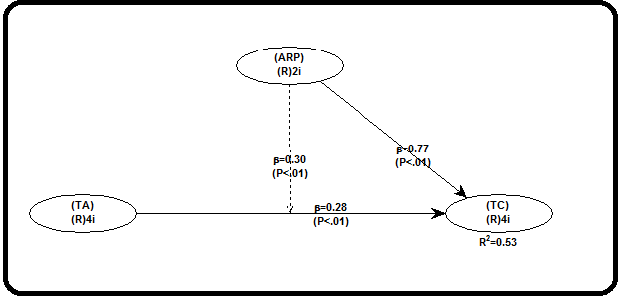
Figure 1. Structural Model
Figure 1. The model of structural equation shows the direction of influence between the variables built in this model that are adapted to the proposed research hypothesis. Explanation of the influence between the variables and the coefficient of path between the variables can be shown in the following table:
Table 6. Estimation and hypothesis testing
Final Model | (TA) |  | (ARP) |  | Moderating
 | Path coefficient  (effect size) | P-value | Path coefficient  (effect size) | P-value | Path coefficient  (effect size) | P-value
(TC) | 0,276 (0,116) | 0,002 | 0,768 (0,592) | <0,001 | 0,300 (0,174) | <0,001

  - Taxpayer’s awareness has a positive and significant impact on taxpayer compliance.
The effect of taxpayer awareness on taxpayer compliance on WarpPLS5.0 program is described in linear form through curve s., where high taxpayer awareness proved able to improve taxpayer compliance. This can be interpreted that if there is an increase in the awareness of taxpayers, it will increase taxpayer compliance of 0.276. R-Squared value can be seen on effect size of 0.116 or 11.60% and the remaining 88.40% influenced by other variables. The coefficient value is a positive sign of 0.276, for that can be shown in the picture below:
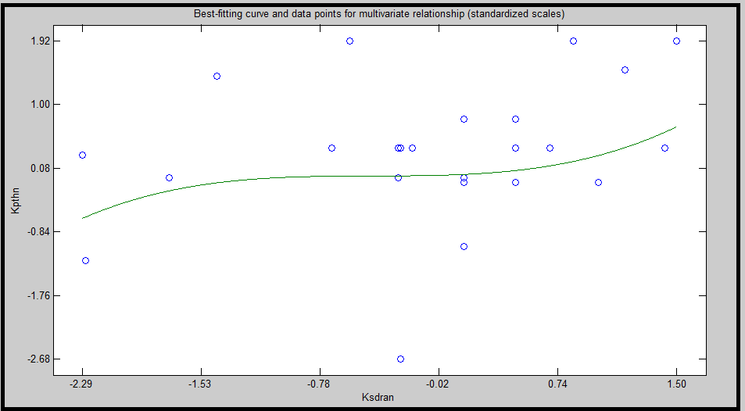
Figure 2. Curve s. linking of awareness on taxpayer compliance
The results of this study provide evidence that the taxpayer awareness have a positive and significant impact on taxpayer compliance this is evidenced by the positive sign coefficient value of 0.276, so it can be interpreted that the higher of taxpayers the awareness can be make the higher level of taxpayer compliance. Then it can also be proved by the probability value of 0.002 < = 0.05. The results of hypothesis testing (H₁) prove that the higher of taxpayer’s awareness then have an impact on the higher level of taxpayer compliance. This means the increase in taxpayer awareness in the direction of real and improvement taxpayer compliance, so the hypothesis that this research is the taxpayers awareness have a positive and significant impact on taxpayer compliance in KPP Pratama North Makassar can be accepted or supported by empirical facts.
Positive and significant influences value are caused because taxpayers have a high tax awareness is evidenced by the fulfillment of tax obligations that are seen as the consequences of citizens and citizen involvement in national development through their obligations as citizens proved able to give a meaningful impact on the high level of compliance compulsory taxes evidenced by the ability of taxpayers to calculate the tax correctly proved by the foresight and obedience and taxpayer accuracy to calculate their tax liabilities correctly. The results of this study support social learning theory (Bandura, 1977), that taxpayers (citizens) will be obedient to pay taxes on time, if through observation and direct experience of the taxpayer, the results of levies the tax has made a real contribution to development in its territory. Taxpayers will be aware to fulfill their obligations thereby impacting taxpayer compliance higher. The results of this study support the findings of some previous researchers (Dewi & Merkusiwati, 2018; Kesumasari &Suardana, 2018; Purba, 2018) that taxation awareness has a significant positive effect on taxpayer compliance. These results are different from the findings of other researchers, that consciousness is not significant effect on taxpayer compliance. This means the taxpayer considers that the obligation in paying taxes has no direct added value to him (Hidayati, 2014; Nugroho et al., 2016; Ndona, 2018).
  - Account representative employee’s performance has a positive and significant impact on taxpayer compliance
Account representative employee’s performance to taxpayer compliance, described in linear form through curve s., where the account representative employee’s high performance proved able to improve taxpayer compliance. This can be interpreted that if there is an increase in account representative employee’s performance, it will increase taxpayer compliance of 0.768. R-Squared value can be seen on effect size of 0,592 or equal to 59, 20% and the rest equal to 40, 80% influenced by other variables. The coefficient value is positive sign of 0.768, for it can be proved in the following figure:
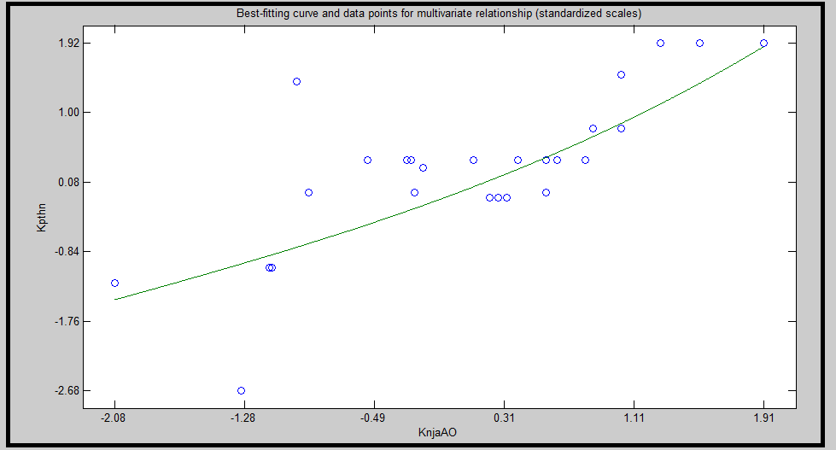
Figure 3 Curve s. Linking of Account representative employee’s performance on taxpayer compliance
The results of this study provide evidence that the account representative employee’s performance has a positive and significant impact on taxpayer compliance. This is evidenced by the positive sign coefficient value of 0.768, so it can be interpreted that the higher performance generated account representative employee it can be make the higher level of taxpayer compliance. Then it can also be proved by the probability value of 0.001 < α 0.05. Hypothesis testing results (H₂) proves that the higher level of account representative employee’s performance is proven the higher levels of taxpayer compliance. This means that the account representative employee’s performance in the same direction and the real toward the improvement of taxpayer compliance, so that the hypothesis in this study is the account representative employee’s performance has a positive and significant impact on taxpayer compliance on KPP Pratama North Makassar can be accepted or supported by empirical facts.
The positive and significant influence is caused because of the high of account representative employee’s performance is evidenced by the high quality of service provided by account representative to the taxpayer indicated by the account representative's employee’s willingness to receive complaints and provide information and other tax services to taxpayers are done to the maximum increase taxpayer compliance is evidenced by taxpayer compliance in reporting their tax obligations by filling out the tax form that has been prepared, in addition to the tax consultation process conducted account representative employee’s performance to the taxpayer proved to improve taxpayer compliance to pay tax on time proved by the taxpayer's obligation to pay the tax before the specified date or time limit. The results support previous research that the account representative employee’s performance positive and significant impact on tax compliance (Alfiansyah & Venusita, 2012; Setiawan, 2017; Ulyani, 2017).
The findings of this study rejected the results of research from other researchers, that the account representative employee’s performance has a positive and insignificant effect on taxpayer compliance (Muammarsyah, 2011; Ashari et al., 2017). In addition, this study is relevant to the study conducted by Sandi (2010) that the account representative employee’s performance characterized by service and supervision has a positive and significant impact on taxpayer compliance, but denied the research findings in other dimensions, i.e. on the dimensions of consultation have a positive and insignificant effect on taxpayer compliance.
  - Taxpayer awareness has a positive and significant effect on taxpayer compliance: The moderating role of account representative employee’s performance.
Linking of taxpayer awareness on taxpayer compliance: The moderating role of account representative employee’s performance is represented in linear form through Curve S., where high taxpayer awareness proved able to increase taxpayer compliance with reinforced account representative employee’s performance. This can be interpreted that if there is an increase in the taxpayer’s awareness, it will increase the taxpayer compliance moderated account representative employee’s performance of 0.300. The R-Squared value can be seen on the effect size is a 0.174 or 17.40% and the rest of 82.60% influenced by other variables. The test results of moderating variables provide evidence that taxpayer awareness has a positive and significant impact on taxpayer compliance: The moderating role of account representative employee’s performance. This is evidenced by the positive sign coefficient value of 0.300, so it can be interpreted that the high of taxpayer’s awareness resulted in high with taxpayers compliance reinforced of account representative employee’s performance.
The coefficient value is a positive sign of 0.300, for it can be proved in the following figure:
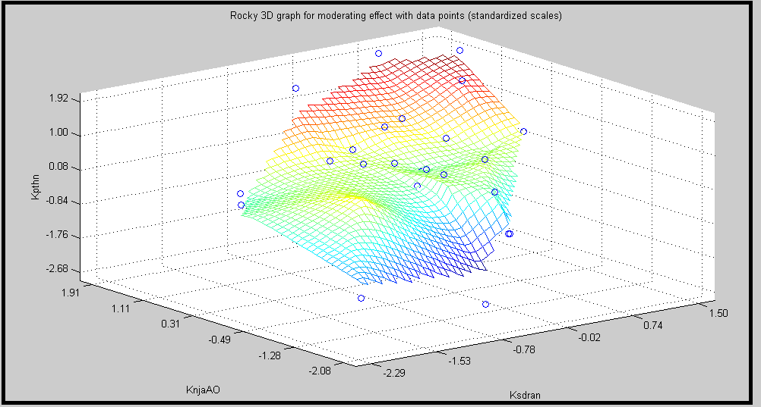
Figure 4. Contributions of account representative employee’s performance
Then it can also be proved by the probability value of 0.001 <α = 0.05. Results of testing the hypothesis (H₃) demonstrate that the higher level of taxpayer’s awareness then have an impact on the increasing levels of taxpayer compliance reinforced of account representative employee’s performance. This means that the increase in tax payer awareness in the direction of taxpayer compliance is supported by the account representative employee’s performance, so the hypothesis in this research is the taxpayer’s awareness has a positive and significant impact on taxpayer compliance: The moderating role of account representative employee’s performance KPP Pratama North Makassar acceptable or supported by empirical facts.
Positive and significant influences are caused due to the high of taxpayers awareness indicated by the fulfillment of tax obligations that are seen as the involvement of citizens in national development through their obligations in paying taxes and then there is reinforced by account representative employee’s performance which indicated the high quality of services provided to the taxpayer so as to prove capable of providing a meaningful impact on the high level of taxpayer compliance shown through the ability of taxpayers to calculate the tax correctly proved by the foresight and obedience and accuracy of taxpayers to calculate their tax liabilities correctly. The results of this study differ from the findings Research by Prihastanti & Kiswanto (2015) that the taxpayer compliance Rate of the agency against tax revenue is further weakened by the tax audit (account representative employee’s performance) as a moderating variable. Then the results of this study are similar to the findings by Kiswara & Jati (2016) that the role of account representative employee’s performance has a significant effect on taxpayer compliance.

Conclusion and recommendations

The contribution of taxpayers' awareness and account representative employee’s performance to taxpayer compliance of 0,520 or 52.00% of the rest of 48.00% is influenced by other variables that are not analyzed. The value of predictive of Q-Squared = 0.654 or 65.40%. This means the accuracy or accuracy of this research model can explain the diversity of taxpayer awareness variable to taxpayer compliance in moderation of representative account performance of 65.40%. The remaining 34.70% is explained by other variables not found in this research model.
Taxpayer’s awareness has a positive and significant impact on taxpayer compliance. This means the consciousness of the taxpayer in the direction and real to the improvement taxpayer compliance. This is caused because taxpayers have high tax awareness as evidenced by the fulfillment of taxation obligations that are seen as the consequences of citizens and citizen involvement in national development through their obligations as citizens proved able to give a significant impact on the high level of taxpayers compliance proved with the ability of taxpayers to calculate the tax correctly proved with carefulness and obedience and taxpayer accuracy to calculate their tax liabilities correctly.
The account representative employee’s performance has a positive and significant impact on taxpayer compliance. This means that the account representative employee’s performance the indirection of real and uniform improvement of taxpayer compliance is caused due to high performance is account representative evidenced by the high quality of service provided by account representative to the taxpayer indicated by the account representative's willingness to receive complaints and provide information and tax services other to the taxpayer is done to the maximum thereby improving taxpayer compliance proven with taxpayer compliance to pay tax on time proven with the obligation of taxpayers to pay tax before the date or deadline that has been set.
Taxpayer awareness has a positive and significant effect on taxpayer compliance in moderation of account representative employee’s performance. This means that the increase in tax payer awareness toward the improvement of taxpayer compliance reinforced or supported by account representative employee’s performance caused by the high level of the taxpayer awareness indicated by the fulfillment of taxation obligation which is seen as the involvement of citizens in national development through their obligation in paying taxes and then there is support (strengthened) account representative employee’s performance that indicated the high quality of services provided to taxpayers so as to prove capable of providing a meaningful impact on the high level of taxpayer compliance is shown through the ability of taxpayers to calculate the tax correctly proved by foresight and obedience and accuracy taxpayers to calculate their tax liabilities correctly. To the KPP Pratama North Makassar is suggested to increase the awareness of the taxpayer through the improvement of the tax function, that the taxpayer has not been fully aware if the tax usage collected from the community will be used to finance the development of the State.
This condition is caused by many facts found by the taxpayer if the taxes they paid during this time are often misused by certain parties (corrupted). Improving the performance of account representative can be done through improvements in tax supervision, that the ability of the taxation apparatus in carrying out supervisory functions because the low (not yet optimal) examination and investigation conducted account representative that affect the performance improvement account representative Improvement of taxpayer compliance can be done through increased understanding of taxation, that taxpayers have a low tax understanding, evidenced by their low knowledge of the provisions of the law taxation in force Regulation of the Minister of Finance.No.74 / PMK.03 / 2012. To account representative should provide better service in the future which can be done through hospitality in the service and the provision of tax information to the maximum and the acceleration of the process of taxation services. To the advanced researchers are advised to develop this research model through the addition of variables that affect taxpayer compliance and expansion of research areas to obtain unbiased results.

References
- Alfiansyah, F., & Venusita, L. (2012). Influence Account Representative (AR) Against Personal Taxpayer Compliance (KPP Pratama Sidoarjo Utara). Journal of Accounting UNESA, 1 (1).
- Arum, HP (2012). The influence of taxpayers' awareness, tax service, and tax sanction on taxpayer compliance of private persons conducting business activities and free employment (study in kpp pratama cilacap region) (Doctoral dissertation, Faculty of Economics and Business).
- Ashari, A., Widodo, US, & Utami, RH (2017). Sunset Polycy Influence. Tax Amnesty, Tax Sanction, E-SPT and Performance Account Representative to tax compliance level. in proceedings of national & international seminars.
- Bandura, A. (1978). Social learning theory of aggression. Journal of communication, 28 (3), 12-29. https://doi.org/10.1111/j.1460-2466.1978.tb01621.x
- Dewi, SK, & Merkusiwati, NKLA (2018) Effect of Taxpayer Awareness, Taxation Sanction, E-Filing, and Tax Amnesty Against Taxpayer Reporting Compliance. E-Journal of Accounting, 1626-1655.
- Diana, Sari. (2013). Basic Taxation Concepts. Bandung: PT Refika Adimata
- Hasanuddin, R., & Sjahruddin, H. (2017). The Structure of Emotional Intelligence, Spiritual Intelligence and Its Relationship with Work Enthusiasm and Auditor Performance. World Journal of Business and Management, 3(1), 67. http://dx.doi.org/10.5296/wjbm.v3i1.11321
- Herryanto, M., & Toly, AA (2013). Effect of taxpayer awareness, tax dissemination activities, and tax audit on income tax revenue in KPP Pratama Surabaya Sawahan. Tax & Accounting Review, 1 (1), 124
- Hidayati, IF (2014). Effect Analysis of Taxpayer Awareness, Knowledge and Understanding About Tax Regulation, Tax System Effectivity, Fiscal Services, and Tax Sanction on Personal Taxpayer Compliance (Case Study at KPP Pratama Surakarta) (Doctoral dissertation, Muhammadiyah University of Surakarta).
- Kesumasari, NKI, & Suardana, KA (2018). Influence Knowledge Taxation, Awareness and Knowledge Tax Amnesty On WPOP Compliance in KPP Pratama Gianyar. E-Journal of Accounting, 1503-1529.
- Kiswara, D., & Jati, IK (2016). The Effect of E-Filing Application and the Role of Account Representative Against the Imaging Tax Authorities and Compliance Taxpayers. E-Journal of Accounting, 349-377.
- Kock, N. (2011). Using WarpPLS in e-collaboration studies: Mediating effects, control and second order variables, and algorithm choices. International Journal of e-Collaboration (IJeC), 7(3), 1-13. https://doi.org/10.4018/jec.2011070101
- Mardiasmo. (2011) Taxation. Edition Revisi.Yogyakarta: Publisher Andi.
- Muammarsyah, N. (2011). Influence of representative account role, understanding taxpayer tax procedure, and service quality of integrated service place in tax office on taxpayer compliance in fulfilling its tax obligation (case study at eight pratama tax service office in South Jakarta).
- Ndona, YR (2018). Analysis of the influence of awareness, tax knowledge and tax amnesty program on taxpayer compliance (Doctoral dissertation, Widya Mandala Catholic University Surabaya).
- Nugroho, A., Andini, R., & Raharjo, K. (2016). The Effect of Taxpayer Awareness And Knowledge Taxpayer Taxpayer Compliance Taxpayer In Paying Income Tax (case study at KPP Semarang Candi). Journal of Accounting, 2 (2).
- Prihastanti, R., & Kiswanto, K. (2015). Compliance rate of corporate taxpayer against tax revenue is moderated by tax audit. Accounting Analysis Journal, 4 (1).
- Purba, Afrizal. M (2018). The Effect of Taxpayer Awareness, Fiscal Services, Taxpayers and Tax Sanctions Against the Formal Compliance Rate of Individual Taxpayer at Batam Primary Tax Office. Journal of Accounting Barelang, 2 (1),
- Republic of Indonesia (2009). Law No. 16 of 2009 on General Provisions and Procedure of Taxation
- Republic of Indonesia (2012). Regulation of the Minister of Finance No. 162 / PMK.011 / 2012 On Adjustment to the Amount of Non Taxable Income
- Republic of Indonesia. (2012). Regulation of the Minister of Finance.No.74 / PMK.03 / 2012. about the criteria of obedient taxpayers.
- Republic of Indonesia. (2013). Regulation of the Director General of Tax No. PER-03 / PJ / 2013 About. Guidance Counseling Taxation, Directorate General of Tax
- Sandi, NB (2010). Analysis of the influence of consulting services, and account representative oversight of taxpayer compliance: empirical studies at Tangerang and Serpong tax office.
- Setiawan, A. (2017). Influence Performance Account Representative, Self Assessment System, and Tax Inspection Against Taxpayer Compliance Level. Equilibrium: Scientific Journal of Economics, 12 (1), 77-90.
- Sholihin, M., & Ratmono, D. (2013). Analysis of SEM-PLS with WarpPLS 3.0 for Nonlinear Relations in Social and Business Research. Yogyakarta: Andi Publisher.
- Trisnayanti, IAI, & Jati, IK (2015). Effect of Self Assessment System, Tax Inspection, and Tax Billing on Value Added Tax (VAT). E-Journal of Accounting, 292-310.
- Ulfah, S. (2018). Effect of Tax Corruption Perception, Service Quality, Tax Knowledge, Tax Sanction, and Religiosity to Taxpayer Compliance. Faculty of Economics of Islamic University of Indonesia
- Ulyani, T.A. (2017). The influence of the taxpayer's perceptions on the application of e-system and account representative to compliance (study at tax office pratama kendari). Journal of Accounting, 1 (2).
- Waluyo, & Wirawan, B.Ilyas. (2011). Indonesian Taxation, Book One, Edition 10. Jakarta: Publisher Salemba Empat.

